Chapter 7, Solution 17.

Consider the circuit of Fig. 7.97. Find v₀(t) if i(0) = 6 A and v(t) = 0.

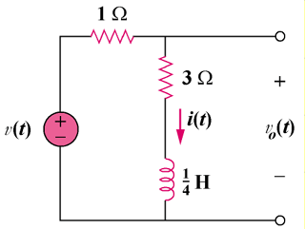

Figure 7.97
For Prob. 7.17.

Solution
,

–6e^{–16t}u(t) V

